PROTEUS DIAGRAMS

Lab Task No. 01:
Three Resistors in a Parallel Circuit Combination
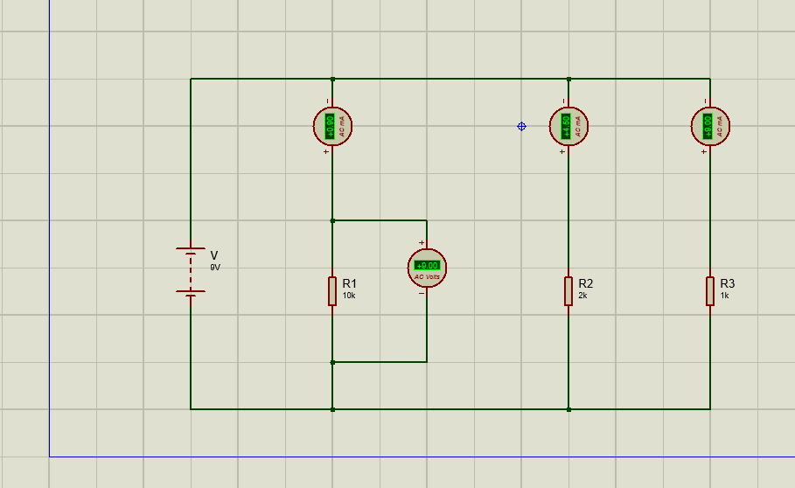

Diagram Explanation:
- A 9V source connected in parallel combination with R1(10k), R2(2k) and R3(1k).
- 3 ammeters in series with R1, R2 and R3 to measure individual branch current.
- One voltmeter across R1 in parallel connection, showing a reading of +9.00V.
Lab Task no. 02:
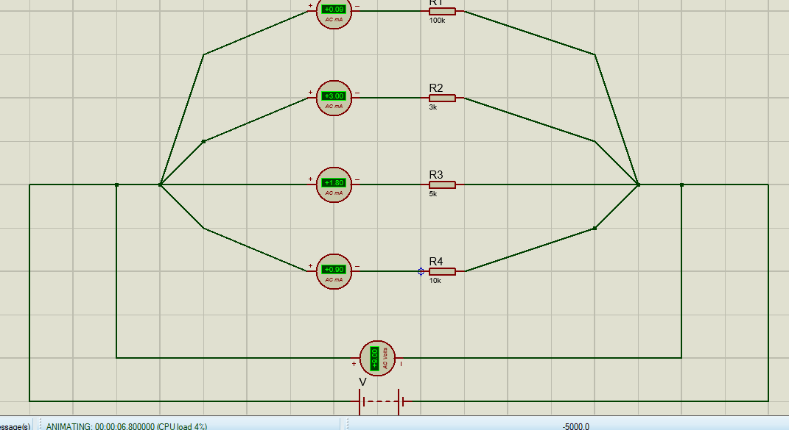
Four resistors in a parallel circuit combination

Diagram Explanation:
- A 9V source is connected in parallel combination with R1 (100k), R2 (3k), R3 (5k) and R4 (10k).
- Four ammeters are connected in a series with R1, R2, R3 and R4 respectively to measure the individual branch currents.
- One voltmeter is connected in parallel across the entire combination, showing a reading of +9.00V.

